I already explained ===== how to connect chatgpt API

Take some cloud account

Azure account ======

Azure for students ====== no credit card details ==== 100$ free

College email id ====

Azure for non students ==== credit /debit ===== 200$ free ==== deactivate account

How to create azure free account ===== email credit/debit

Azure ML services ==== keys python

By 26th ========

Linear regression ========= OLS

Logistic regression ======= sigmoid

Decision Tree ========== Entropy /gini

Naïve bayes ========= Probability

KNN ========== distance metric

**Classification Metrics**

1. **Confusion matrix**
2. **Accuracy**
3. **Error rate**
4. **Sensitivity**
5. **Specificity**
6. **Precision**
7. **Recall**
8. **F1-score**
9. **Kohens-kappa**
10. **ROC-AUC curve**

$Confusion matrix:$

$Generally in a data , target column has two labels yes and no$

$Model also will predict yes and no$

**Age gender income cr y**

**30 M 50k fair yes**

**You develop the model ====== train data to the model**

**{30,M,50K,fair} ============ yes No**

**How many total combinations**

**Actually yes ,model predicted as No**

**Actually yes, model predicted as yes**

**Actually No , model predicted as No**

**Actually No, model predicted as yes**

$True postive \left(TP\right)=actually yes, model predicted as yes$

$True negative \left(TN\right)=actually no,model predicted as no$

$False postive \left(FP\right)=actually No, model predicted as yes$

$False negative \left(FN\right)=actually yes, model predicted as No$

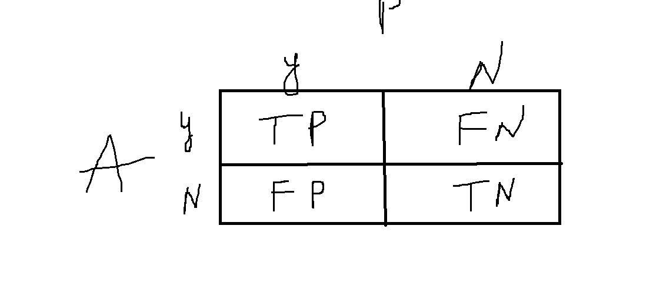

**In a data originally 50 yes are there , 50 No are there**

**Model is predicted 40 yes and 60 No**

**Create the Confusion matrix**

$True postive \left(TP\right)=10$

$True negative \left(TN\right)=20$

$False postive \left(FP\right)=30$

$False negative \left(FN\right)=40$

$Total observations=TP+TN+FP+FN$

$Accuracy: \frac{Tp+Tn}{Total observations}=\frac{Tp+Tn}{Tp+Tn+Fp+Fn}=\frac{10+20}{100}=30\%$

$Error rate:1-0.3=70\%=1-Accuracy$

$Case-1:$

$Avesh khan got a requirement from DMART owner$

$They are requesting him to create a ML model to identify a terrosit$

$He develop the model$

$originally there 100 members are there in that$

$99 members are not a terrorist, 1 person is the terrorist$

$99 NO 1 Yes$

$Model is identify correctly the persons , those who are not a terrorist$

$but model is fail to identify who is actually a terrorist$

$what is the accuracy of model:99, 1,$

$99 NO ======99 NO$

$1 yes========No$

**Tp=0 tn=99 99+0 = 99**

$will feel that model is very good because accuracy is 99\%$

$but it is fail to detect the actual need$

$Accuracy of a model is not prime metric$

$postive analysis and negative analysis$

$True postive rate= out of total postives how many model actually predicting$

$TPR=\frac{TP}{P}$

$only one yes is there P=1$

$TP=0$

$TPR=0\%$

$True negative rate=out of total actual negatives, how model is predicting no$

$TNR=\frac{TN}{N}$

$Number of No=99, model is predicting 99=\frac{99}{99}=100\%$

$TPR=0 TNR=100\% Accuracy=99\%$

$TPR=sensitivity$

$TNR=specificity$

$in above problem there two classe yes and no$

$yes=1 no=99 ratio: 1:99===== >class imbalance problem$

$accuracy will fail in class imbalance problem$

**Tomorrow you have a class 9am**

**Azure ml studio Mlops**

**Confusion matrix**

**TP TN FP FN**

**FP ===== > model is predicting yes but it is wrong**

**Actually no**

**Accuracy**

**Error rate**

**Class imbalance problem:**

**Yes No**

**100**

**90 10**

**80 20**

**95 5**

**Classes are imbalanced accuracy will fail**

**How to deal with class imbalance problem**

**99 yes 1 No**

**Cancer patient detection**

**Health related rare**

**99 yes 1 No ======== to make the balance**

**Add data**

**1 -=========== 99**

**99 ============ 1**

1. **Up sampling**

**You will concentrate on lower label observation**

**You will increase those observations**

**No cases**

**30 M 50k No**

**31 M 50k No**

**30 F 50k No**

1. **Down sampling**

**99:1**

**2000 8000**

**4000 4000**

**Red green yellow**

**200 200 200 600**

**LLM fine tuning**

**Google**

**Spam reviews data**

1. **Website**
2. **Telephone**
3. **Google maps**

**285 reviews 12Yes NO**

**50 reviews 13 277 NO run the model**

**5 1 yes 4NO**

**TPR= True positive rate = Tp/p ========= sensitivity**

**TNR= True negative rate= Tn/n ======== specificity**

**Sensitivity =0 specificity= 99 accuracy =99**

Precision and Recall

$precision and recall concentrate only on True postives$

$senario-1$

$actually some postive observations are there,$

$in that how many model is predicting correctly$

$senario-2$

$model is predicting some postive, in that how many are matching with actuals$

$Precision=\frac{TP}{TP+FP}$

$TP+FP=== >model postive predictions$

$out of model postive predictions, how many matching with actuals$

| **X** | **Y** | **Y_pre** |
| --- | --- | --- |
|  | **Yes** | **No** |
|  | **Yes** | **Yes** |
|  | **Yes** | **Yes** |
|  | **No** | **Yes** |
|  | **No** | **No** |

**Qn) How many actual positives are there = 3**

**Qn ) How many model predicted positives are there =3**

**Qn) How many model positive predictions are matching with actual positives=2**

$Precision=\frac{TP}{TP+FP}=\frac{2}{3}=0.66$

$Recall=\frac{TP}{TP+FN}=\frac{2}{3}=0.66$

$TP+FN=== >actual postives$

$out of actual postives , how many matching with model (Recall)$

$out of model postive predictions, how many matching with actuals(Preision)$

| **Classes** | **Yes** | **No** | **Total** | **Recognition** |
| --- | --- | --- | --- | --- |
| **Yes**  **No** | **90(TP)**  **140(FP)** | **210(FN)**  **9560(TN)** | **300**  **9700** | **30.00%**  **98.56%** |
| **Total** | **230** | **9770** | **10,000** | **96.40** |

$Precision=\frac{TP}{TP+FP}=\frac{90}{230}=0.39$

$Recall=\frac{TP}{TP+FN}=\frac{90}{300}=0.3$

$Interpretation Precision:0.39≅0.4 M==== >A$

$out of total model postive pedictions 40\% are matching with actual$

$if model is predicting 100 observations as postives,$

$in that only 40 are matching with actual$

$Interpretation recall:A==== >M$

$out of total actual postives , 30\% only matching with model$

$P:M==== >A$ $M=TP+FP$

$R:A==== >M$ $A=TP+FN$

$sensitivity=\frac{TP}{P}=\frac{TP}{TP+FN}=Recall$

$Which is important Precision or recall?$

$FP=model is predicting true, actual is negative$

$you are not a terrorist ,model is predicting terrorist$

$FN=model is predicting no, actual is yes$

$you are a terrorist ,model is predicting no$

$problem based , generally recall$

$F-1 score:$

$DT: P:85 R=80$

$NB:P:80 R=85$

$KNN:P:83 R:81$

$Haromonic mean of Precision and recall$

$F_{1}=\frac{2*Precision*Recall}{Precision+Recall}$

$Accuracy=\frac{\left(TP+TN\right)}{TP+TN+FP+FN}$

$Error rate=1-Accuracy$

$Sensistivity=TPR=\frac{TP}{P}$

$Specificity=TNR=\frac{TN}{N}$

$precsison=\frac{TP}{TP+FP}$

$recall=\frac{TP}{TP+FN}=\frac{TP}{P}=TPR$

$F_{1}=\frac{2*Precision*Recall}{Precision+Recall}$

$ROC-AUC:$

$RMSE-MSE-MAE-MAPE$

$Cross entropy=-y*logy-(1-y)*log(1-y)$